**Interview Key Points**

**Position**

**Position Summary**

* Lead data system analytics for OSU Graduate School
  + Career Development Center (80 page report with 5 years of student and financial data)
* Assist associate Dean in assessment processes
* Work with graduate school leadership on projects that advance data informed decision making
  + 5 Year plan to help graduate students (provide funding, financial support matriculation)
  + This is all data and analysis drive and I excel at this.
  + Increase GTA for Ecampus
* Primary contact for data related activities
  + Organized
    - Restructured Server
    - Restructured Staff Drive (same for at least 10 years)
* Responsibilities
  + Annual assessment and evaluation process
  + Data Provision and data systems development
  + Extracting data from OSU systems

**Position Duties**

* Annual Graduate Program Assessment and bi annual evaluation process (20%)
  + Deliver annual data profiles to all graduate programs
  + Assist in full cycle assessment process
* External Program Reviews (15%)
  + Lead implementation of data systems that support external program reviews
  + Support the associate Dean and VPD during external program review site visits
  + Support programs in the development of their self study documents
* Data Provision and Data Systems Development (20%)
  + Develop and lead key data projects internally and externally
    - CORE reports, survey of earned doctorate, exit survey, alumni survey
  + Support graduate school leadership with data system requests
  + Complete specialized requests for data that come to us from other offices internally
* Primary Data Liaison (20%)
  + Serve as primary liaison for metrics and data initiatives with other offices on campus
* Assist associate dean with analytics (15%)
  + Support graduate schools strategic plan and ongoing benchmarking efforts around key metrics of graduate success
* Accreditation (10%)
  + Assist Associate Dean and VPD for accreditation efforts

**Technology**

Banner

Data Warehouse

* Current business intelligence tools no longer meet the evolving business needs of the University. Thus, the University has decided to move from the current data warehouse solution to Ellucian software products ODS (Operational Data Store) and EDW (Enterprise Data Warehouse). In addition, a new reporting tool will be installed and implemented. BRM (Banner Relationship Management), RAP (Recruiting and Admissions Performance) and SRP (Student Retention Performance) will also be implemented.

Academic Analytics

**Graduate School**

**Summary:**

* We advance Oregon State University's teaching, research, and outreach goals by supporting graduate students in all aspects of their education. Our goal is to ensure that every student has the opportunity to succeed.
* Together with graduate faculty, we provide financial support for our students to ensure that we attract the very best and brightest students to advance our research agenda.
* We provide opportunities for our students to acquire the skills that they will need to be successful in their future career.

And we ensure that every program is engaged in continuous improvement so that our students can be assured of the highest quality graduate education available anywhere in the world.

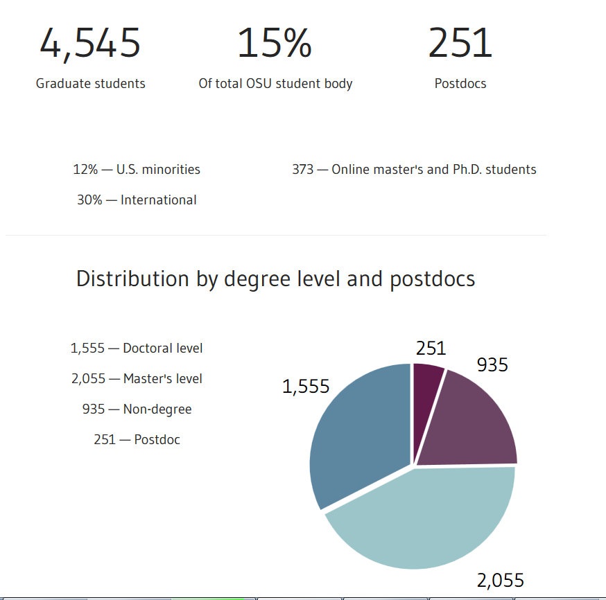

**OSU**

**Core Values**

* Accountability. We are committed stewards of the loyalty and good will of our alumni and friends and of the human, fiscal, and physical resources entrusted to us.
* Diversity. We recognize that diversity and excellence go hand-in-hand, enhancing our teaching, scholarship, and service as well as our ability to welcome, respect, and interact with other people
* Integrity. We practice honesty, freedom, truth, and integrity in all that we do.
* Respect. We treat each other with civility, dignity, and respect.
* Social responsibility. We contribute to society’s intellectual, cultural, spiritual, and economic progress and well-being to the maximum possible extent.

**SQL**

Wildcard %

**INNER JOIN**

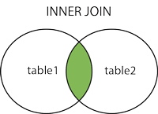

* 1. Left Join- The LEFT JOIN keyword returns all rows from the left table (table1), with the matching rows in the right table (table2). The result is NULL in the right side when there is no match.

**LEFT JOIN**

*SELECT column_name(s)*

*FROM table1*

*LEFT JOIN table2*

*ON table1.column_name=table2.column_name;*

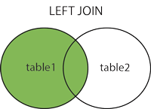

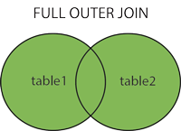

* 1. Union- The UNION operator is used to combine the result-set of two or more SELECT statements.Notice that each SELECT statement within the UNION must have the same number of columns. The columns must also have similar data types. Also, the columns in each SELECT statement must be in the same order.

*SELECT Orders.OrderID, Customers.CustomerName, Orders.OrderDate*

*FROM Orders*

*INNER JOIN Customers*

*ON Orders.CustomerID=Customers.CustomerID;*

1. How would you write a SQL SELECT statement?
   1. *SELECT * FROM Customers;*
2. There were some standard db/sql questions such as differentiate between inner/left outer joins, indexes, etc as well as open ended questions such as tuning strategy/methodology for a slow application query, etc
   1. Inner Join- The INNER JOIN keyword selects all rows from both tables as long as there is a match between the columns in both tables.

*SELECT column_name(s)*

*FROM table1*

*INNER JOIN table2*

*ON table1.column_name=table2.column_name;*